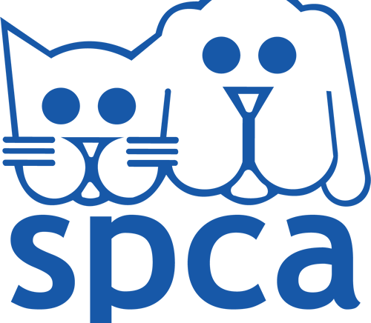
DURBAN & COAST SPCA
Web Development
Tshireletso Pakwe | ST10533502 | WEDE5020

Table of Contents
Organisation Overview 2
Website goals and objectives 3
Current website analysis 4
Proposed website features and functionality 5
Design and user experience 6
Technical requirements 7
Timeline and milestones 8
Budget 9
References 10

Organisation Overview
Durban and coast SPCA is a registered non-profit organization that works to prevent animal cruelty and improve animal welfare in the greater Durban area. Founded in 1896, it is the largest SPCA in KwaZulu Natal. Its services include animal rescue, sheltering stray and unwanted animals, veterinary care, animal welfare inspections, human education and responsible pit ownership initiatives. The organization also operates from multiple locations including its Springfield park head office and Phoenix satellite branch.
The target audience is pet owners, people interested in animal adoption, volunteers, donors, sponsors, community members and people reporting animal cruelty.

Website goals and objectives
The proposed website redesign will have two main goals:
- Improve accessibility to information by making services, adoption information, contact details and animal welfare resources easier to find.
- Increase community engagement by encouraging visitors to adopt, volunteer, donate and reports animal cruelty.

KPIs
- Adoption enquiries submitted.
- Volunteer and sponsorship enquiries.
- Online donations or donation page visits.
- Animal cruelty reports or enquiries submitted online.

Current website analysis
The existing website provides valuable information including services, adoption listing, news, donation opportunities and multiple contact details. However, large amounts of information and numerous contact options could make navigation and information discovery more difficult for some users. A redesign could improve the information hierarchy, simplify navigation and create clearer calls to action for adoption, donations and volunteering.

Proposed website features and functionality
The redesigned website will include:
- Home page with important announcements and calls to action.
- About us, page containing history, mission and impact.
- Animal adoption page with available animals.
- Services page.
- Volunteer or donation or enquiry functionality.
- Contact page with locations, contact details and map.
- Responsive navigation and mobile friendly layouts.

Design and user experience
The design will use a caring, trustworthy and professional visual style that reflects animal welfare. A clear color palette, readable typography and strong animal photography will create an approachable experience. Information will be organized into clear sections with prominent buttons such as “adopt, donate, volunteer and report cruelty”. The website will be responsive and accessible across different screen sizes.

Technical requirements
The website will be developed using:
- HTML5 for page structure.
- CSS3 for styling and responsive layouts.
- JavaScript for interaction function at its scene.
- A responsive design approach for desktop, tablet and mobile devices.
- Web hosting and suitable domain name.

Timeline and milestones
- Research and proposal - 1 week.
- Sitemap and wireframes - 1 week.
- HTML and CSS development - 1 to 2 weeks.
- Testing, debugging and finalization - 1 week.

Budget
Item | Estimated cost
Domain | R105 yearly
Hosting | R1,188 yearly
Website Development | Student developed – R0
Maintenance | R600 yearly
Estimated initial cost | R1,893

References

